# Abstract

Highway agencies continue to implement tolls primarily to mitigate traffic congestion and to generate revenue. As public private partnerships continue to pick up pace in infrastructure delivery and operations, it has become increasingly important to evaluate the feasibility of various road tolling approaches and to measure the risks and uncertainties associated with toll road investments. The need for such evaluation is particularly realized for time-of-day (TOD) tolling approaches. This paper describes the development and implementation of a simulation framework and accompanying software tool to estimate, for various time-of-day (TOD) tolling scenarios, the expected impacts in terms of traffic flow patterns, traveler route choices, amount of travel, travel time, revenue, and social welfare, compared to a base case scenario (no toll). The results of the case study corroborate the assumptions or findings of past researchers who touted the efficacy of TOD tolling as an effective congestion-mitigation and revenue-generation strategy. The paper also measured the extent to which the impacts of tolling extends beyond just the toll road itself to the adjacent roadways. Therefore, a case is made herein for holistic approaches in road toll evaluation (i.e., to use a broader spatial scope that includes neighboring roads) instead of a standalone manner (the toll road only). The framework reduces drastically, the time and effort in evaluating proposed future TOD tolling initiatives and can be applied to other prospective tolling locations. The visualization feature illustrates traffic diversions from the toll road to neighboring routes due to tolling implementation and displays the most-impacted road segments in the study area. Furthermore, the accompanying software tool can be integrated seamlessly with standard software packages for demand analysis and geospatial visualization.

*Keywords*: Time-of-day tolling, Road pricing, Tolling, User charges, Distributional impacts, Revenue forecast.

# Introduction and Motivation

Over the past two decades, numerous agencies have implemented tolls on their highway, bridge, or tunnel infrastructure for purposes that include congestion mitigation and revenue generation. Regarding revenue generation, it is worth noting that increasing shortfalls in road construction and maintenance funding continue to motivate federal, state, and local governments to solicit alternative mechanisms of infrastructure financing particularly from the private sector. As such, the last two decades has witnessed unprecedented growth in the use of public private partnerships (P3s) for infrastructure delivery and operations, and most P3s exist in the form of road or bridge tolls. Agencies acknowledge that the decision to implement tolling is based on several assumptions that are fraught with uncertainty and risk. To proactively quantify these risks and thus verify the feasibility of proposed tolling, agencies carry out ex ante studies that include demand and cost predictions. Then, after the tolling is implemented, they carry out ex poste studies to ascertain the extent to which the initial assumptions are validated by actual conditions. Studies of these kinds are important to address the current limited understanding of the scope and extent of TOD tolling impacts including shifts in route choices and increased demand at routes that receive traffic diverted from the toll road. Furthermore, traditional ex ante methods of tolling evaluation such as surveys and public hearings need to be supplemented by projections of demand, traffic flow patterns, amounts of travel and travel delay, and revenues. With this knowledge, transportation agencies are placed in a better position to make decisions on where, when and how much to toll.

In 2015, the Indiana Department of Transportation (INDOT) sought to investigate the feasibility of time-of-day (TOD) tolling at the Indianapolis’s Interstate 465 ring road, a high-volume beltway that connects Interstates 65, 70, 74, and 69, four national corridors that play a vital and strategic role connecting the northern, southern, western, and eastern parts of the country. The agency therefore commissioned a research study to assess the feasibility of TOD tolling, in terms of various performance indicators related to the agency, the road user, and the community.

This paper documents the development and implementation of a simulation framework and software tool that address this research need. The paper describes a case study involving prospective tolling of a part of Interstate 465 (I-465). The paper is organized as follows. Section 1 presents introduction and motivation for this study. Section 2 introduces literature review on related topics. Section 3 describes methodology used in the study. Section 4 presents the case study and insights earned from the analysis and Section 5 concludes he paper and suggests possible directions for future research.

# Literature review

## The Impacts of Road Tolls

Toll roads have a diverse range of impacts. Some of these are benefits and others are disbenefits. Also, some impacts are borne by the road user while others are borne by the agency, the concessionaire, and the community. Overall, the performance indicators for these impacts include traffic congestion, revenues, travel demand, changes in route choices, land use shifts, impacts on neighboring local roads, economic development, citizens’ welfare (Supernak et al., 2002; Gupta et al., 2006; de Palma et al., 2008; Kristoffersson, 2013).

Highway and bridge tolls typically serve as an extra source of income for financing the construction, operation, and maintenance of this infrastructure. Steer Davies Gleave (2013), studied the impact of tolling two Ohio River bridges in the Louisville metropolitan area and concluded that the annual tolling revenue will be $34 million for the first half year of opening, and over $210 million in 10 years.

Besides generating considerable revenue, tolling is also shown to be an effective road-pricing approach in reducing traffic congestion (Akiyama and Okushim, 2006; Lindsey, 2006; Pierce, 2014; Pessaro and Van Nostrand, 2014) which otherwise impairs economic development and decreases air quality and quality of life. As a demand-side congestion-mitigation strategy, road pricing schemes including tolling has been implemented in several big cities worldwide. For example, Singapore launched the Electronic Road Pricing scheme in 1998 and charges road users a congestion fee every time they cross the cordon area (Goh, 2002). In 2003, London introduced the zonal congestion-pricing scheme wherein a daily fee is charged for every vehicle within the congestion-charging zone. A few studies have also carried out conceptual evaluation of the impacts on congestion pricing in roadways (Fan, 2016; Cao et al., 2017).

Also, road tolling can yield economic benefits (NCSL 2004; Wilbur, 2005; Weisbrod and Williams, 2011; Lauridsen, 2011; Steer Davies Gleave, 2013), impact regional traffic, land use, economy and welfare in a positive or negative way (Gupta et al., 2004; Ferrari, 2005; Kleist and Doll, 2005; Lemp and Kockelman, 2009; Kockelman and Lemp, 2011; Ungemah, 2013; Petrella et al., 2014; Ray et al., 2014). It can also be used an effective congestion management strategy and helps to lower fuel consumption and vehicular emissions (Santos and Newbery, 2001; Goh, 2002; Ramjerdi et al., 2004; Kleist and Doll, 2005; Waersted, 2005). Further, certain types of tolling can be used to manage traffic congestion. For example, TOD tolling charges different tolls for peak and non-peak hours, thereby discourages travel at peak periods.

## Types of Toll Implementation

*2.2.1 Flat Rate Tolling*

The most common type of tolling is fixed tollingwhich is a toll rate that is flat over time but may vary by vehicle class. This type of tolling is typically implemented for well-defined, special and relatively costly infrastructure, such as bridges, tunnels, mountain passes.

*2.2.2 Time of Day Tolling*

Time-of-day tolls impose different level of tolls at different times of the day and typically is lower during off-peak hours. The objective is to address inefficient tolling where there is a mismatch between the individual cost and the marginal cost (Arnott et al., 1994; Holguín-Veras and Allen, 2013). In addition to generating additional revenue for managing roadways, this strategy allows drivers who are willing to pay, to use the highway. Drivers who are not willing to pay a toll can change their travel time, route, mode, or choose not to travel (Glaister, 1981). This change in travel behavior of drivers, impacts the region’s traffic, land use, economy and welfare.

*2.2.3 Distance/area based Tolling*

Tolling based on distance/zone, involve vehicles charged based on the total distance driven on the road or specific areas entered. Distance-based tolling is used to reduce the use of the facility, while zone based tolling is used to reduce the number of vehicles entering a specific area. Tolls that try to manage congestion charges the user according to the congestion levels of the transportation system. It serves to reduce the traffic congestion of the specified area (Nakamura and Kockelman, 2002; Issariyanukula and Labi, 2011). Table 1 presents a summary on the objectives, scope, and implementation cost and complexity of the different types of toll implementation.

**TABLE 1 Characteristics of different types of toll implementation**



## Mechanisms for Toll Evaluation Studies

Light et al. (2015) used stated preference surveys, traffic and revenue estimation and scenario testing to solicit the perspectives of motorists regarding a proposed TOD tolling scheme. Supernak et al., 2002; McKinnon, 2006; Kristoffersson, 2013; Wang and Goodchild, 2014; Fan, 2016 used computer simulation to assess the impacts of fixed tolling and TOD tolling. Wu et al. (2011) developed a Matlab simulation tool to evaluate the effectiveness of TOD tolling on managed-lane operations.

## Temporal Relativity of Past Tolling Studies

The impacts of any transportation stimulus can be assessed before (ex ante) or after (ex poste) the stimulus occurs (Sinha and Labi, 2007). Ex ante studies are carried out to proactively estimate the demand, revenue, and other performance measures, and thus provide a basis for quantifying the investment risks associated with road tolling and ultimately, to assess the overall feasibility of proposed tolling from the perspective of all key stakeholders (the agency, the concessionaire, the road user, and the community). Ex poste studies assess the levels of these indicators to ascertain the extent to which the initial assumptions are validated by actual conditions.

*2.4.1 Ex Ante Evaluations*

In the United States, most tolling studies have been ex ante in nature. For this, the Texas DOT uses a toll feasibility analysis procedure to screen and evaluate candidate toll projects (TxDOT, 2007). Colorado DOT carries out similar procedures for evaluating tolling projects (Wilbur, 2005). Steer Davies Gleave (2013) carried out an ex ante study of the Ohio River Bridges in the Louisville metropolitan area on the Indiana/Kentucky border.

*2.4.2 Ex Poste Evaluations*

The post-implementation impacts of tolls have been studied for many road projects at different locations worldwide, and these experiences provide useful guidance on the impact analysis and feasibility of future road tolling proposals (Zhang et al., 2013). In Washington State, Seattle’s SR-520 is a typical example of a toll-road project that received ex poste impact evaluation. The Evergreen Point Floating Bridge, built parallel to the existing bridge, was forecasted to have very high future traffic volumes, and was tolled by time of day and day of week, starting December 2011. A survey was carried out on over 2,700 households to evaluate the influence of the tolling policy on traveler behavior and other impacts, revealed a significant decline in overall travel on SR-520 and significant traffic diversion to toll-free alternative routes and transit (WSDOT, 2016).

Eliasson and Mattsson (2006) studied the effects of tolling in Stockholm by measuring the distributional effects across persons of different classes (income, gender, family situation, occupational status, location, and car ownership). The tolling impacts were expressed in terms of the changes in travel cost, travel behavior, and travel times, and amount of revenue generated. Fridstrøm et al. (2000) studied the economic and equity impacts of marginal-cost tolling in Edinburg, Helsinki, and Oslo. These researchers predicated their study on the assumption that the marginal road user is charged the marginal cost of road use which consists of the costs of congestion, environmental degradation, accidents, and other road user-generated costs – external or internal. They determined that marginal-cost tolling increases the annual social welfare gains for the three cities by 100-400 euros per capita. Kickhöfer et al. (2010) used multi-agent microsimulation of individual traveler behavior to study the impact of tolling in Zurich. The model allowed for multiple-choice dimensions simultaneously, such as route choice, mode choice and time choice, and assumed that each agent sought to maximize their individual utility function (which was input as a function of their income). The study demonstrated that tolling can and does often result in negative impacts on the welfare distribution of the society. Zhang et al. (2014) carried out an ex poste evaluation of the 2006 long-term lease of Indiana’s Interstate 90 toll road.

## New Road-Toll Challenges

New toll projects always have project-specific issues and challenges. A recent survey of state transportation officials by the U.S. Government Accountability Office (GAO) (2006) identified two broad categories of challenges: those associated with obtaining support and these associated with implementation and listed four key questions to be addressed (Table 2).

Table 1 Questions to be considered for new toll road projects (adapted from GAO (2006))



Each of the above issues listed by the GAO study is relevant. Tolling equity is an important issue that has multiple dimensions including income equity, geographic equity and modal equity. It is important that transportation officials address all these dimensions. Inequitable impacts on low-income groups can be addressed by providing them with credits (Schweitzer and Taylor, 2008). Regarding tolling demand forecast reliability, Odeck and Morten (2017) reported that the predicted traffic predictions for several prospective toll road projects were overestimated, and that this situation caused financial distress for the toll operators. Hence, it is critical that forecasting methods are more accurate and discount for lower traffic volumes due to tolling, based on the concept of demand elasticities. Also, tolling can have significant impacts on logistics and business activities and transport decisions (Ruehl et al., 2013): in the short term, logistics operators increase load factors by horizontal and vertical cooperation (Einbock, 2006); in medium term, they transfer tolling costs to the customers; and in the long term, they switch to another transport mode.

# Methodology

The framework in this paper involves the use of static traffic assignment to compute the various impacts of a prospective time of day toll on a select portion of the Indiana road network. The overall framework is (Figure 1), comprises of (a) the statewide network level which focuses on the statewide travel demand modeling and (b) the subarea network level which addresses the TOD tolling implementation on the subarea of interest.

## Travel Demand Modeling for the Overall Jurisdiction

The step involves the use of an appropriate travel demand model that draws on an underlying database of roads on the jurisdiction where the toll road is located. Key elements of the travel demand model are that it has (a) a road network and traffic analysis zones including road inventory data at each year (b) traffic signal locations, for estimating a realistic value for link impedances, (c) trip generation models that are based on recent census data, (d) Gravity model factors including updated friction factor curves to reflect the current or forecast transportation network, (e) trip assignment that involves multiple volume-delay functions.

## Modeling the Subarea TOD Tolling

The travel demand model is designed to report daily auto and truck volumes assigned to the network. However, to accurately determine the TOD tolling impact (particularly in terms of mobility and revenue), there is a need for the proposed model to report the traffic volumes at each time of day (for example, the AM peak period, AM off-peak period, PM peak period, or the PM off-peak period) for each link in the subnetwork. The directional traffic volume can be estimated from the total traffic volume and directional factors. To achieve the traffic assignment at the desired periods, two procedures were used (a) a TOD trip table generation procedure: an OD trip table that contains the travel demand of different vehicles (autos and trucks) for the TOD was created, and (b) a traffic assignment procedure: the directional link-based traffic volume of each link in the subarea needs to be determined based on the TOD trip table.

Traffic assignment is carried out for autos and trucks in each TOD period using the Multi-Modal Multi-Class Assignment (MMA) function, a built-in function of TransCAD 7. This traffic assignment model based on the generalized cost differentiated by individual modes and user classes (vehicle types). Other assignment models exist in TransCAD 7; however, MMA was chosen because it can help to avoid the issue of loading all vehicle classes to the network at the same time. Furthermore, to be consistent with the existing model structure, the generalized cost is calculated in MMA using the travel time and toll costs, and is then used to execute the trip distribution and traffic assignment.

The TOD tolling is implemented on the network by inputting the toll costs for each corridor, trip purpose and vehicle type. The first step in the TOD tolling implementation involves skimming the subarea based on free-flow time, and the associated toll costs along the links, using the Toll Shortest Path functionality in TransCAD 7. Next, the toll costs are converted to time units via purpose-specific value-of-time (VOT) which is also used in traffic assignment process. Then the specific generalized cost impedances based on the travel time plus the converted toll time (Toll cost/VOT) are determined. Finally, these generalized cost impedances are used in the MMA gravity model. After the traffic assignment, the results are collated to carry out the impact analysis. Figure 1 presents the steps for the TOD tolling implementation.

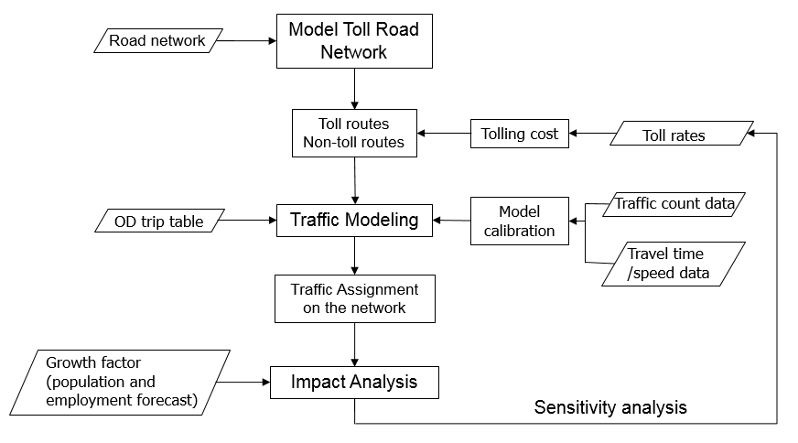

FIGURE 1 Overall framework for analyzing the impacts of the TOD tolling

# Case study

The case study involves Interstate 465 (I-465) which has a total length of about 57.5 miles (92 km) and has major interchanges not only with other major interstate highways but also major high-volume arterials in the Indianapolis region. Due to the “crossroads” nature of its location, I-465 continues to experience sustained and significant growth in travel demand, and recurring congestion of traffic has been observed at some road segments that are directly connected to I-465. To address this problem, the Indiana Department of Transportation (INDOT) is carrying out, among other initiatives, tolling the I-465 corridor. Therefore, this case study investigates the feasibility of tolling the I-465 and it is also sought to assess the potential impacts of various tolling scenarios on the roads in the neighboring nine-county region. The Indiana Statewide Travel Demand Model (ISTDM) Version 6 was used for the analysis. This model uses an underlying database of the state highways, county roads, and local street networks in all ninety-two counties (or 4,831 TAZs) in the state. ISTDM is the main modeling tool used at the highway agency to assess its system performance, long-range plans and system-level projects at the statewide level. Some ISTDM features are: (1) network and traffic analysis zone (TAZ) developments: INDOT’s Road Inventory Data (RID) for each year is attached to the roadways network. The TAZ structure is refined by adding a significant number of TAZs in Indiana. The following section presents the results from the analysis on I-465 and its surrounding nine-county region, and a discussion of the insights earned from the analysis.

# results and insights

Multiple scenarios were established for the analysis. The truck toll rates are assumed to be double that of autos. In addition, the rates in off-peak hours are half of the peak hour rates. The peak hours are 6:00AM to 9:00AM (morning peak), and 3:00PM to 6:00PM (afternoon peak); other hours are off-peak. The scenarios differ by toll rate and the reference scenario or base case is the no-toll scenario. Table 3 presents the scenario details.

**TABLE 3 Toll Scenarios ($/mile)**

|  |  |  |  |  |
| --- | --- | --- | --- | --- |
|  | Peak | | Off-Peak | |
|  | Auto | Truck | Auto | Truck |
| Base | 0.000 | 0.000 | 0.000 | 0.000 |
| Scenario 1 (S1) | 0.030 | 0.060 | 0.015 | 0.030 |
| Scenario 2 (S2) | 0.040 | 0.080 | 0.020 | 0.040 |
| Scenario 3 (S3) | 0.050 | 0.100 | 0.025 | 0.050 |
| Scenario 4 (S4) | 0.060 | 0.120 | 0.030 | 0.060 |
| Scenario 5 (S5) | 0.070 | 0.140 | 0.035 | 0.070 |
| Scenario 6 (S6) | 0.080 | 0.160 | 0.040 | 0.080 |
| Scenario 7 (S7) | 0.090 | 0.180 | 0.045 | 0.090 |
| Scenario 8 (S8) | 0.100 | 0.200 | 0.050 | 0.100 |

The impacts of each scenario were determined for each of the years 2010, 2015, and 2025. The results were then displayed to show the traffic flow distributions in the network. The results also present visualization of the traffic flow, showing the most impacted road segments. In addition, the developed tool was designed to integrate with Google Maps, and therefore additional information of the study area can be visualized (Figure 3). As shown in the figure, the I-465 toll implementation affects traffic flows on the roads that are directly or indirectly connected with I-465. These results are intuitive because it suggests, quite expectedly, that travelers will seek to avoid paying tolls and instead use alternative routes to reach their destinations, and in doing so, they do not significantly increase their travel times. As shown in Figure 3(b), the most impacted road segments are I-69 North and I-465. The observed increase in traffic flow maybe due to the significant growth in Noblesville, Fishers and the northern part of Indianapolis.

Figure 4 presents an increasing trend of annual revenues for the years 2010, 2015, and 2025. The revenues are all converted into 2017 dollars’ value. As expected, the base case (no toll) and scenario 8 (highest toll) for all three future years have lowest and highest revenues, respectively. The revenue for the 8 scenarios increases monotonically with increasing toll rate but the marginal increase in the revenue falls as the toll rate increases. In fact, the increase in tolls yield revenue increase only up to a certain point. Therefore, at a high enough toll rate, the revenue drop (Figure 2). Also, the gap between the 2025 revenue versus 2015 revenue as compared to the gap between 2015 revenue versus 2010 revenue is higher due to the additional five-year difference in the former case.

In addition, the 2010 revenues are slightly lower than 2015 revenues, while there is a larger gap between the 2015 revenues and 2025 revenues. Regarding TOD revenue distributions (Figure 5a), similar diurnal trends across 2010, 2015, and 2025 can be observed. The revenues are lowest from midnight to about 6:00 AM since there is less traffic in those hours; and highest during AM peak hours (6:00 AM – 9:00 AM) and PM peak hours (3:00 PM – 6:00 PM). The revenue at PM peak is higher and has a larger amplitude compared to the AM peak.

The total VHT is lowest from midnight to 6:00 AM, and then spikes up to hit its morning peak at 8:00 AM. It falls at 9:00 AM and reaches its lowest point during the daytime at 10:00 AM. VHT gradually increases and sharply rises to its maximum at 5:00 PM. It then falls at 7:00 PM and increases to a secondary peak at 8:00 PM. The secondary peak may be due to people’s activity outside of work hours. For example, the travelers may be making restaurant trips in the downtown area after work (when the first peak happens), then drive back home (the second peak happens). The VHT then gradually decreases until midnight. From 6:00 PM to midnight, the travel time gradually reduces to its lowest level. The VHT in the base scenario is always higher than that other scenarios and scenario 8 has lowest VHT. The VHT at peak hours always rises in subsequent years from 2010 to 2025 as seen in Figure 5(b).

The average speed is inversely proportional to the average travel time as can be seen at Figure 5(d). The average speed is low during the 7:00 AM – 9:00 AM period and through the 3:00 PM – 9:00 PM period. It sharply decreases to its lowest AM value at 8:00 AM, and reaches its absolute minimum speed at 5:00 PM. Also, there is a secondary low point at 8:00 PM. The average speed gradually increases from the base case (no toll) to scenario 8 (highest toll). This suggests that by paying a higher toll, travelers can earn a much higher travel speed. From midnight to approximately 6:00 AM, the average travel speed is fairly stable for all scenarios because there may be less traffic during that time and therefore vehicles can move at the designated speed limits at each road section. It can be observed that the decrease in average travel time and increase in average speed during the peak periods from the base case to scenario 8 range from 5% to 8.5%; this represents a significant alleviation of traffic congestion. This reinforces the case for implementing variable tolls.

With regard to the overall consumer welfare, the post-tolling impacts for the nine counties put together is observed to be negative across the 2010 to 2025 period. A negative welfare indicates that the change in monetary cost for a given scenario i.e., the monetary equivalent of travel time of the commuters using the toll road in a particular toll scenario plus total sum of the toll paid by the commuters using the facility is higher than the base case scenario monetary equivalent of the travel time. The monetary equivalent of travel time equals to the VOT multiplied by travel time. Therefore, if the overall consumer welfare is negative, then the monetary equivalent of the travel time savings on the toll road is not enough to offset the total toll that the consumers have to pay to use the toll road (I-465). Negative welfare is observed across all scenarios from 2010 to 2025. From Figure 6(a), (b), and (c), it can be observed that Marion County (located at the center of the map) is the most negatively-impacted region. Hamilton County (located at the middle-top right of the map) is slightly negatively impacted in 2010 and then most positively-impacted in both of years 2015 and 2025.

Figure 6 presents the welfare levels of each of the nine counties due to the I-465 toll implementation. The regions marked yellow do not have any welfare impacts. A significant portion of I-465 is located in Marion County. In addition, a high percentage of the traffic volume on I-465 is in that county (Indiana Public Data Utility). Therefore, we observe a high fraction of the overall negative welfare (green color) across the nine counties occur in Marion County. It is seen, on the other hand, that Hamilton County benefits positively as that county has many trips generating from Hamilton to Marion and also in the reverse direction. Marion County experiences a welfare impact that worsens as the toll rate increases as shown in Figure 6 as an increasingly darker shade of green color. On the other hand, Hamilton County has a higher positive welfare impact as the toll rate increases (as shown in the figure with increasingly darker shade of orange color with progressively higher toll rate).

This paper’s findings are largely consistent with those of past researchers. Kristoffersson, (2013) analyzed the tolling schedule in Stockholm and varying the tolling schedule to observe the effect on travel behavior. The results of time-varying toll are similar to those of this paper as evidenced by the reduction of traffic volumes in the toll ring. Wang et al. studied the effect of tolling on truck travel time, travel time reliability and route choice. The results of that study is consistent with those of the present paper (Wang et al observed that there is a perceptible increase in vehicle speed on the toll road after the toll is implemented). In addition, Wang et al. (2014) showed that vehicle’s route choices change significantly after the toll is implemented and a certain percentage of vehicles shift to the roads without toll. Another similar study by Wu et al. (2011) also shows results that are in accord with those of the present paper. They showed that vehicle speeds on TOD toll roads are generally significantly higher compared with roads with fixed toll. Clearly, the TOD toll is more effective because it incentivizes non-peak hour travel and penalizes peak-hour travel, and therefore is effective in reducing travel demand. These past studies on TOD impacts did not consider other tolling impacts such as welfare. The welfare consequences of congestion pricing but not TOD tolling specifically, were investigated by other researchers (Ferrari, 2002; Gupta et al., 2006; Kalamanje and Kockelman, 2004; Kockelman and Lemp, 2011; Parry and Bento, 2002).

|  |  |
| --- | --- |
| **Screen Clipping** |  |
| 1. **An example of traffic impacts at adjacent roads due to tolling on I-465** | 1. **The most-affected roads** |

**FIGURE 3 Example of traffic distributions**

FIGURE 2. Toll revenue as a function of toll rate

FIGURE 4 Annual revenues

|  |  |  |  |
| --- | --- | --- | --- |
| |  | | --- | |  | |  | |  |   FIGURE 5 (a) Time-of-day Distribution of Revenue |

|  |  |  |  |
| --- | --- | --- | --- |
| |  | | --- | |  | |  | |  |   FIGURE 5 (b) Time-of-Day Distribution of VHT |

|  |  |  |  |
| --- | --- | --- | --- |
| |  | | --- | |  | |  | |  |   **FIGURE 5 (c) Time-of-Day Distribution of Average Travel Time** |

|  |  |  |  |
| --- | --- | --- | --- |
| |  | | --- | |  | |  | |  |   **FIGURE 5 (d) Time-of-day Distribution of Average Speed** |

# Conclusions

Highway agencies continue to implement tolls primarily to mitigate traffic congestion and to generate revenue. As public private partnerships continue to pick up pace in infrastructure delivery and operations, it has become increasingly important to evaluate the feasibility of various road tolling approaches and to measure the risks and uncertainties associated with toll road investments. The need for such evaluation is particularly realized for the time-of-day (TOD) tolling approach which is relatively less common compared to static tolling (constant toll rates irrespective of the time of day). This paper describes the development and implementation of a simulation framework and accompanying software tool to estimate, for various time-of-day (TOD) tolling scenarios, the expected impacts in terms of traffic flow patterns, traveler route choices, amount of travel, travel time, revenue, and social welfare, compared to a base case scenario (no toll).

The paper’s framework includes a methodology that captures the relationship between the TOD toll and route choice and quickly evaluates the various impacts of various TOD tolling policies. The framework facilitates visualization of the resulting traffic flows on roadways and identifies the roads that are most impacted by the toll on the toll road. The framework also enables the quantification of revenues, travel times, speeds, total traveler delay, and the total amount of travel. The framework estimates these impacts for the no-toll scenario, various TOD scenarios, and a scenario where toll rates do not change by time of day. The framework reduces drastically, the time and effort in evaluating proposed future TOD tolling initiatives and can be applied to other prospective tolling locations. The visualization feature illustrates traffic diversions from the toll road to neighboring routes due to tolling implementation and displays the most-impacted road segments in the study area. Further, the accompanying software tool can be integrated seamlessly with standard software packages for demand analysis (such as Transcad) and geospatial visualization (such as Google Maps and Google Earth), thus making available a vast amount of additional information for users. The framework is applicable to toll roads at any location.

In its case study, the paper used travel demand data from a highway agency in Midwestern United States for each of the years 2010, 2015 and 2025, and the analysis determined that TOD tolling has a significant impact in terms of the above metrics. For each scenario, there was increasing revenues (adjusted for inflation) from 2010 to 2025 mostly due to traffic growth. Regarding the diurnal variation, the revenue was found to peak at 8:00 AM and during the 4:00 PM – 6:00 PM period, and the lowest revenues occurred from midnight to 6:00 AM. The amount of revenue is a direct reflection of the combination of traffic volume and the share of truck traffic in the traffic stream. The total travel time and the average varies during times of day and through the years. It is lowest from 12:00 AM to 6:00 AM and highest at 8:00 AM and during 4:00 PM – 6:00 PM. The total travel time generally increases at peak times in the subsequent years from 2010 to 2025. Moreover, the average travel times have similar patterns as those of total travel times. The average speed trends are inverse to those of the average travel time: speeds reduce during peak time hours unlike non-peak hours. Under conditions of higher toll rates, travelers can operate at higher speeds.

The results of the case study corroborate the assumptions or findings of past researchers who touted the efficacy of TOD tolling as an effective congestion-mitigation and revenue-generation strategy. The paper also measured the extent to which the impacts of tolling extends beyond just the toll road itself to the adjacent roadways. Therefore, a case is made herein for holistic approaches in road toll evaluation (i.e., to use a broader spatial scope that includes neighboring roads) instead of a standalone manner (the toll road only).

Summing up, this paper provided insight into the multi-dimensional impacts of time-of–day tolling. The paper considered a TOD toll with a fixed departure time and static TOD tolling. This work can be extended to explore the impacts of dynamic departure times and dynamic TOD tolling, not for a single corridor but for part or all of a given network, in terms of the performance metrics used in this paper. Further, future work could incorporate a wider range of performance measures including travel time reliability. Also, other ways of measuring social benefits could be considered.

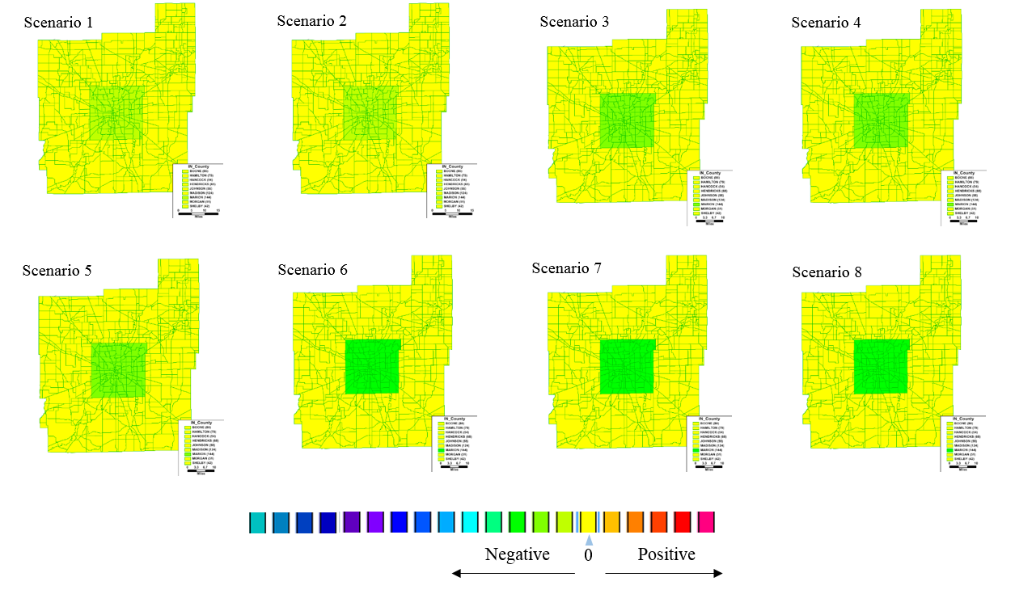

FIGURE 6(a) Welfare outcomes visualization, Year 2010

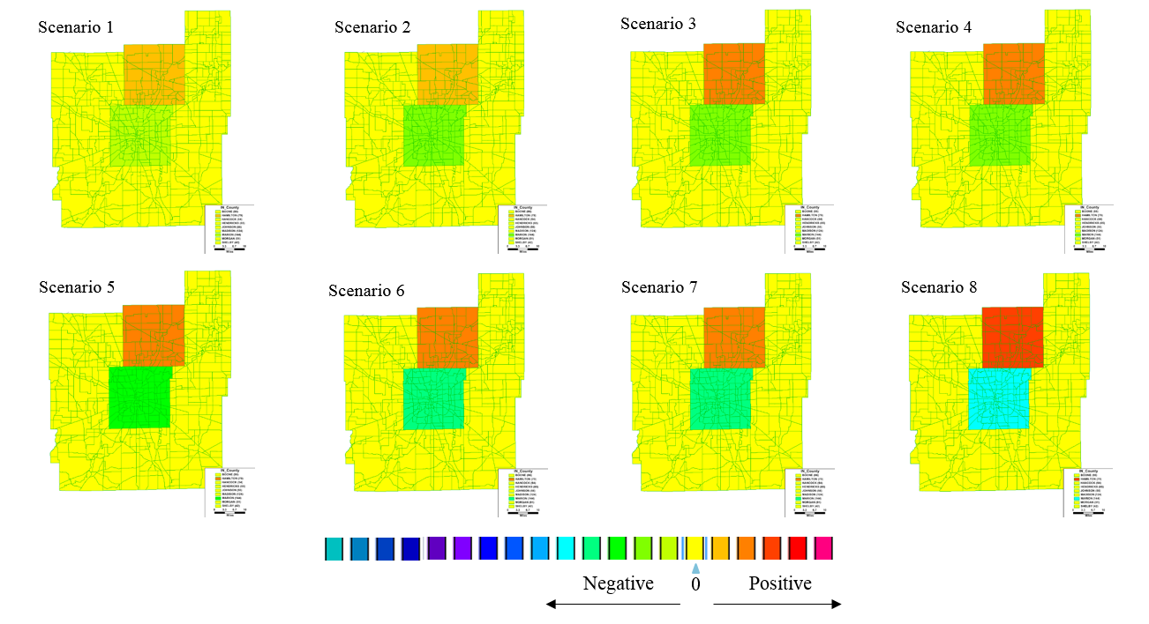

**FIGURE 6 (b) Welfare outcomes visualization, Year 2015**

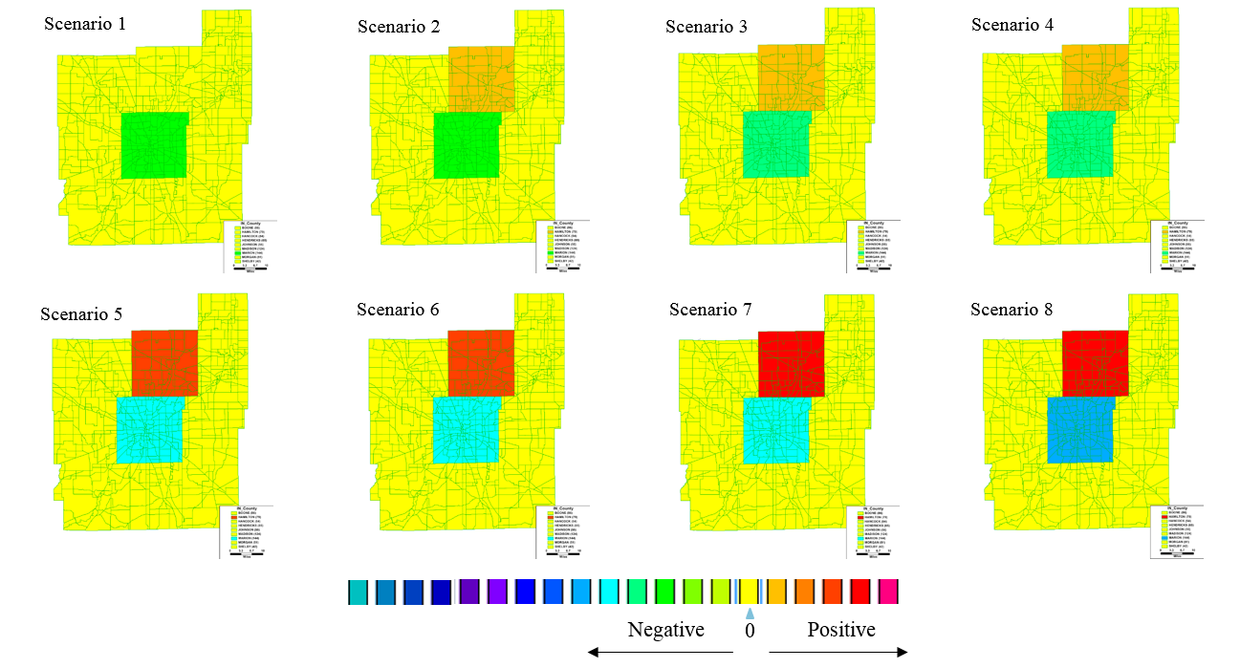

FIGURE 6 (c) Welfare outcomes visualization, Year 2025

**FUNDING**

This work was sponsored by Indiana Department Of Transportation (INDOT), USA [grant numbers SPR 3911, 2014), and supported in part by the Joint Transportation Research Program administered by the INDOT and Purdue University.

**ACKNOWLEDGEMENT**

The authors would like to thank our colleagues from INDOT Roy Nunnally, Samy Noureldin, Korey Chu, Emanuel Nsonwu, and Frank Baukert who provided insights and expertise that greatly assisted the research. An extended abstract of this paper has been submitted to TRB 2018 for a conference presentation.

**REFERENCES**

Akiyama, T., Okushima, M., 2006. Implementation of cordon pricing on urban network with practical approach. J. Adv. Transp. 40(2), 221–248.

Arnott, R., Small, K., 1994. The Economics of Traffic Congestion, American Scientist. 82, 446–455.

Cao, K., Cheng, Y. Woo, C, 2017. Price-management of traffic congestion: Hong Kong’s Lion Rock Tunnel. Case Studies in Transport Policy.

de Palma, A., Lindsey, R., Wu, F., 2008. Private operators and time-of-day tolling on a congested road network. J. Transp. Econ and Policy 42(3), 397–433.

Einbock M., 2006. Effects of the Austrian road toll system on companies, Int. J. Phys. Dist & Log. Mgmt. 36(2).

Evans, I.V., Bhatt, K.U., Turnbull, K.F., 2003. Traveler Response to Transportation System Changes. Chapter 14-Road Value Pricing, Project No. B-12A FY'99.

Fan, W., 2016. Optimal congestion pricing toll design under multiclass transportation network schemes: Genetic algorithm approaches. Case Studies on Transp. Policy. 4(2), 78–87.

Federal Highway Administration. FHWA route log and finder list. http://www.fhwa.dot.gov/planning/national_highway_system/interstate_highway_system/routefinder/index.cfm. Accessed Jul. 12, 2016

Ferrari, P., 2002. Road network toll pricing and social welfare. Transp. Res. Part B. 36(5), 471–483.

Ungemah, D.H., 2010. Pricing of New Facilities: Fairness and Equity Impacts of Tolling in Austin. Transp. Res. Board 89th Annual Meeting, 10-3152.

Finance, H., 2006. Stated Expanding Use of Tolling Illustrates Diverse Challenges and Strategies. GAO-06554. Government Accountability Office, Washington, DC.

Gilroy, L., Aloyts, D., 2013. Leasing the Indiana Toll Road: Reviewing the First Six Years Under Private Operation. Reason Foundation. Policy Brief No.108.

Glaister, S. Fundamentals of Transportation Economics, Basil Blackwell, Oxford, England, 198.

Steer Davies Gleave., 2013. Louisville-Southern Indiana Ohio River Bridges Traffic & Revenue Study. Final report. <http://updates.kyinbridges.com/wp-content/uploads/2013/08/Traffic-Revenue-Study-8-30-13.pdf>. Accessed Aug. 15, 2014.

Goh, M., 2002. Congestion management and electronic road pricing in Singapore. J. Transp. Geo. 10(1), 29–38.

Gupta, S., Kalmanje, S., Kockelman, K.M., 2006. Road pricing simulations: traffic, land use and welfare impacts for Austin, Texas. Transp. Planning and Tech. 29(1), 1–23.

Holguín-Veras, J., and Allen, B., 2013. Time of day pricing and its multi-dimensional impacts: A stated preference analysis. Transp. Res. Part A. 55, 12–26.

Indiana's Public Data Utility. http://www.stats.indiana.edu/dms4/commuting.asp. Accessed Feb. 15, 2017.

Issariyanukula, A., Labi, S., 2011. Financial and Technical Feasibility of Dynamic Congestion Pricing as a Revenue Generation Source in Indiana: Exploiting the Availability of Real-time Information and Dynamic Pricing Technologies. NEXTRANS, Project No 044PY02.

Eliasson, J., Mattsson, L. G., 2006. Equity effects of congestion pricing. Transport. Res. Part A. 40 (7), 602–620.

Kalmanje, S., Kockelman, K., 2004. Credit-based congestion pricing: travel, land value, and welfare impacts. Transp. Res. Rec. 1864, 45–53.

Kickhöfer, B., Zilske, M., Nagel, K., 2010. Income Dependent Economic Evaluation and Public Acceptance of Road User Charging. Working Paper, TU Berlin.

Kleist, L., Doll, C., 2005. Economic and environmental impacts of road tolls for HGVs in Europe. Res. in Transp. Econ, 11(4), 153–192.

Kockelman, K.M., Lemp, J.D., 2011. Anticipating new-highway impacts: Opportunities for welfare analysis and credit-based congestion pricing. Transp Res Part A. 45(8), 825–838.

Kristoffersson, I., 2013. Impacts of time-varying cordon pricing: Validation and application of mesoscopic model for Stockholm. Transp. Policy. 28, 51–60.

Fridstrøm, L., Minken, H., Moilanen, P., Shepherd, S., Vold, A., 2000. Economic and Equity Effects of Marginal Cost Pricing in Transport, Research Reports 71.Government Institute for Economic Research Finland (VATT).

Lauridsen, H., 2011. The impacts of road tolling: A review of Norwegian experience. Transp. Policy.18(1), 85–91.

Lemp, J., and Kockelman, K., 2009. Anticipating Welfare Impacts via Travel Demand Forecasting Models: Comparison of Aggregate and Activity-Based Approaches for the Austin, Texas, Region. Transp. Res. Rec. 2133, 11–22.

Light, T., Patil, S., Erhardt, G.D., Tsang, F., Burge, P., Sorensen, P. Zmud, M., 2015. The Impact of Adopting Time-of-day Tolling: Case Study of 183A in Austin, Texas. http://www.rand.org/content/dam/rand/pubs/research_reports/RR900/RR969/RAND_RR969.pdf. Accessed Feb. 15, 2016.

Lindsey, R. Do economists reach a conclusion on highway pricing? The intellectual history of an idea., 2006. Econ Journal Watch. 3(2), 292–379.

McKinnon, A.C., 2006. A review of European truck tolling schemes and assessment of their possible impact on logistics systems. Int. J. Log. 9(3), 191–205.

Nakamura, K., Kockelman, K.M., 2002. Congestion pricing and roadspace rationing: an application to the San Francisco Bay Bridge corridor. Transp. Res. Part A. 36(5), 403–417.

NCSL., 2004 Compilation from Highway Statistics, Finance Series. Federal Highway Administration, Table SF-1, 1999–2004.

Odeck, J., & Welde, M., 2017. The accuracy of toll road traffic forecasts: An econometric evaluation. Transp. Res. Part A.101, 73-85.

Parry, I.W.H., Bento, A.M., 2002. Estimating the welfare effect of congestion taxes: the critical importance of other distortions within the transport system. J. Urban Econ. 51(2), 339–365.

Peirce, S., Petrella, M.., Puckett, S., Minnice, P., Lappin, J., 2004. Urban Partnership Agreement and Congestion Reduction Demonstration Programs. Volpe National Transportation Systems Center, Cambridge MA.

Pessaro, B., Van Nostrand, C., 2014. Impacts of Congestion Pricing in Miami, Florida. Traffic Engg & Ctrl. 55(3), 99–103.

Petrella, M., Puckett, S., Peirce, S., Minnice, P., and Lappin, J., 2014. Effects of Full-Facility Variable Tolling on Traveler Behavior: Evidence from a Panel Study of the I-85 Corridor in Atlanta, Volpe National Transportation Systems Center.

Ramjerdi, F., Minken, H., and Østmoe, K., 2009. Norwegian Urban Tolls. Res. in Transp. Econ. 9(1), 237–249.

Ray, R., Petrella, M., Pierce, S., Minnice, P., Puckett, S., Lappin, J., 2014. Exploring the Equity Impacts of Two Road Pricing Implementations Using a Traveler Behavior Survey: Full Facility Pricing on SR 520 in Seattle and the I-85 HOV-2 to HOT-3 Conversion in Atlanta, Volpe National Transportation Systems Center, Cambridge MA.

Ruehl, F., von Mörner, M., Friedrich, H., Özsucu, Ö., 2013. Impacts of HGV tolls on transport logistics. World conference on Transportation Research.

Santos, G., Newbery, D.M., 2001. Urban congestion charging: theory, practice and environmental consequences. CESifo Working Paper Series 568.

Supernak, J., Golob, J., Golob, T., Kaschade, C., Kazimi, C., Schreffler, E. Steffey, D., 2002. San Diego's Interstate 15 Congestion Pricing Project: Attitudinal, Behavioral, and Institutional Issues, Transp. Res. Rec. 1812, 78-86.

Schweitzer, L., & Taylor, B., 2008. Just pricing: The distribu­tional effects of congestion pricing and sales taxes. Transport 35(6), 797–812.

Texas Department of Transport, 2007. TxDOT Open for business. Toll feasibility analysis. ftp://ftp.dot.state.tx.us/pub/txdot-info/library/pubs/bus/open4biz/toll_feasibility_analysis.pdf. Accessed Jul. 10, 2016.

Ukkusuri, S.V., Labi, S., Feng, Z., Le, T.V., Sagir, F., 2017. SPR 3911: Evaluating the Impacts of Time‐of‐Day Tolling on Indiana Roadways. Final Report. Joint Transport Research Program.

Ungemah, D., 2007. This land is your land, this land is my land: Addressing equity and fairness in tolling and pricing. Transp. Res. Rec. 2013, 13-20.

Waersted, K., 2005. Urban tolling in Norway–Practical experiences, social and environmental impacts and plans for future systems. Norwegian Public Roads Administration. PIARC Seminar on Road Pricing with emphasis on Financing, Regulation and Equity, Cancun, Mexico. 11-13.

Wang, Z., Goodchild, A., 2014. GPS Data Analysis of the Impact of Tolling on Truck Speed and Routing: Case Study in Seattle, Washington. Transp. Res. Rec. 2411, 112-119.

Weisbrod, G., Williams, D., 2011. Framework and Process for Economic Impact Assessment of Potential Highway Congestion Pricing and Tolling Schemes. Transportation Research Board 90th Annual Meeting, No. 11-1585.

Wilbur Smith Associates., 2005. Executive Summary - CTE Preliminary Traffic & Revenue Study.

WSDOT, 2016. SR 520 Bridge investment grade, traffic and revenue study update. Washington State Department of Transportation.

Wu, D., Kulshrestha, A., Yin, Y., Tillander, T., Plass, M., 2011. Impacts of Dynamic Pricing on Managed Lane Operations. Transportation Research Board 90th Annual Meeting, No. 11-1772.

Sinha, K.C. and Labi, S. 2007, Transportation Decision-Making: Principles of Project Evaluation and Programming, Wiley and Sons, Hoboken NJ.

Zhang, Z., Bai, Q., Labi, S., Sinha, K.C. (2013) General Framework for Evaluating Long-Term Leasing of Toll Roads: Case Study of Indiana I-90 Highway, Transportation Research Record 2345, 83–91.